

General Sir John Kotelawala Defense University

Department of Electrical, Electronics & Telecommunication Engineering

Machine Learning

ET 4103

Assignment – 02

Regularized Logistic Regression

Index No : D/ENG/22/0120/ET

Name : M. A. E. Wijesuriya

Intake : 39

Submission Date : 20/06/2025

**Q1. Utilize the given Jupyter notebook[1] for Regularized Logistic Regression. Comment on the code and the output of the program, explaining utilized Machine Learning concepts where necessary**

The following code is a python program that demonstrates Regularized Logistic Regression. Logistic Regression is a type of statistical model used to classify data into binary outcomes. It is a supervised learning algorithm that used a sigmoid function to generate probability values for a set of linear inputs. This probability value is then used to classify the data into one of two classes.

Regularized Logistic Regression utilizes a regularization parameter (lambda) that is used to prevent overfitting, by adding a penalty term to the cost function.

Code with Explanation:

(text in *italics,* along with any graphs or tables,are the output of the preceding code segment)

from google.colab import drive

drive.mount('/content/drive') # Grants Colab access to Google Drive in order to retrieve the data files

%cd "/content/drive/MyDrive/ML_files"

*/content/drive/MyDrive/ML_files*

# Importing Libraries

import numpy as np

import pandas as pd

import matplotlib.pyplot as plt

# Retrieving the data file

data_path = 'ex2data2.txt'

data = pd.read_csv(data_path, header=None, names = ["x1","x2","y"])

data.head() # Prints the first 5 rows of the data in a table

|  |  |  |  |
| --- | --- | --- | --- |
|  | x1 | x2 | y |
| 0 | 0.051267 | 0.69956 | 1 |
| 1 | -0.092742 | 0.68494 | 1 |
| 2 | -0.213710 | 0.69225 | 1 |
| 3 | -0.375000 | 0.50219 | 1 |
| 4 | -0.513250 | 0.46564 | 1 |

# Generates a scatter plot of the data with negative data marked with blue dots, and positive data marked with yellow crosses

def plotData(data, label_x, label_y, label_pos, label_neg, axes=None):

    # Get indexes for class 0 and class 1

    neg = data['y'] == 0

    pos = data['y'] == 1

    # If no specific axes object has been passed, get the current axes.

    if axes == None:

        axes = plt.gca()

    axes.scatter(data[pos]['x1'], data[pos]['x2'], marker='+', c='orange', s=60, linewidth=2, label=label_pos)

    axes.scatter(data[neg]['x1'], data[neg]['x2'], c='blue', s=60, label=label_neg)

    axes.set_xlabel(label_x)

    axes.set_ylabel(label_y)

    axes.legend(frameon= True, fancybox = True);

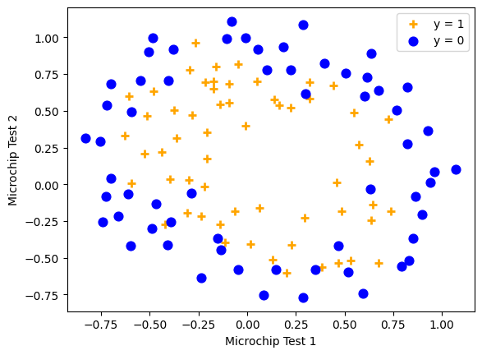

n = data.shape[1]-1

x = data[data.columns[0:n]]

y = data[data.columns[n:n+1]]

# convert to np.array

X = x.values

y = y.values

## Feature mapping

from sklearn.preprocessing import PolynomialFeatures

poly = PolynomialFeatures(6)

XX = poly.fit_transform(X)

print(X.shape, XX.shape) # Shows the change in the array X before and after transformation

*(118, 2) (118, 28)*

## Regularized cost function

m = y.shape[0]

# Defines the Sigmoid function

def sigmoid(z):

    return(1 / (1 + np.exp(-z)))

# Defines the cost function

def Cost(theta, reg, XX,y):

    h = sigmoid(XX.dot(theta))

    J = -1*(1/m)*(np.log(h).T.dot(y)+np.log(1-h).T.dot(1-y)) + (reg/(2*m))*np.sum(np.square(theta[1:]))

    if np.isnan(J[0]):

        return(np.inf)

    return (J[0])

# testing with reg =1

theta_initial = np.zeros(XX.shape[1])

Cost(theta_initial,1,XX,y)

*np.float64(0.6931471805599454)*

theta_initial.shape # Gives the shape of the intial theta value

*(28,)*

## Partial derivative (with regularization)

def gradientReg(theta, reg, *args):

    h = sigmoid(XX.dot(theta.reshape(-1,1)))

    grad = (1/m)*XX.T.dot(h-y) + (reg/m)*np.r_[[[0]],theta[1:].reshape(-1,1)]

    return(grad.flatten())

### Optimization (using the minimize algorithm)

from scipy.optimize import minimize

# reg = 0

res = minimize(Cost, theta_initial, args=(0, XX, y), method=None, jac=gradientReg, options={'maxiter':3000})

res.x.shape # Gives the shape of the optimal theta values

*(28,)*

res.x # Prints the values of the optimal theta for minimizing the cost function

*array([ 35.10191603, 44.11916362, 69.27189416, -344.27909705,*

*-198.23463043, -184.22842064, -295.8204313 , -621.73277966,*

*-510.8493901 , -328.31189673, 1094.70042861, 1269.58591712,*

*1757.74920592, 900.9379677 , 436.58887509, 471.12033517,*

*1236.23866847, 1822.82041592, 1929.66786448, 1131.05336056,*

*463.79937972, -1142.11743445, -2020.95915332, -3463.39994523,*

*-3484.51083578, -3252.2679351 , -1546.00965736, -510.41277032])*

# Binary classifier prediction function

def predict(theta, X, threshold=0.5):

    p = sigmoid(X.dot(theta.T)) >= threshold

    return(p.astype('int'))

accuracy = 100*sum(predict(res.x, XX) == y.ravel())/y.size

accuracy  # for C = reg = lambda = 0

*np.float64(61.016949152542374)*

# Effect of lambda

lambda_set = [0,1,100]

fig, axes = plt.subplots(1,len(lambda_set), sharey = True, figsize=(17,5))

# Decision boundaries

# Lambda = 0 : No regularization (overfitting)

# Lambda = 1 : Looks about right

# Lambda = 100 : Too much regularization --> high bias (underfitting)

x1_min, x1_max = data['x1'].min(), data['x1'].max(),

x2_min, x2_max = data['x2'].min(), data['x2'].max(),

xx1, xx2 = np.meshgrid(np.linspace(x1_min, x1_max), np.linspace(x2_min, x2_max))

B0 = np.linspace(x1_min,x1_max)

B1 = np.linspace(x2_min,x2_max)

Z = np.zeros((B0.size,B1.size))

for i, C in enumerate(lambda_set):

    # Optimize costFunctionReg

    res = minimize(Cost, theta_initial, args=(C, XX, y), method=None, jac=gradientReg, options={'maxiter':3000})

    def h(x1,x2):

        a=poly.fit_transform(np.c_[x1.ravel(),x2.ravel()])

        return sigmoid(a.dot(res.x))

    # Scatter plot of X,y

    plotData(data, 'Microchip Test 1', 'Microchip Test 2', 'y = 1', 'y = 0', axes.flatten()[i])

    # Contour plot

    for p in range (B0.size):

        for q in range(B1.size):

            Z[p,q] = h(xx1[p,q],xx2[p,q])

    axes.flatten()[i].contour(xx1, xx2, Z, [0.5], linewidths=1, colors='red');

    # Accuracy

    accuracy = 100*sum(predict(res.x, XX) == y.ravel())/y.size

    axes.flatten()[i].set_title('Train accuracy {}% with Lambda = {}'.format(np.round(accuracy, decimals=2), C))

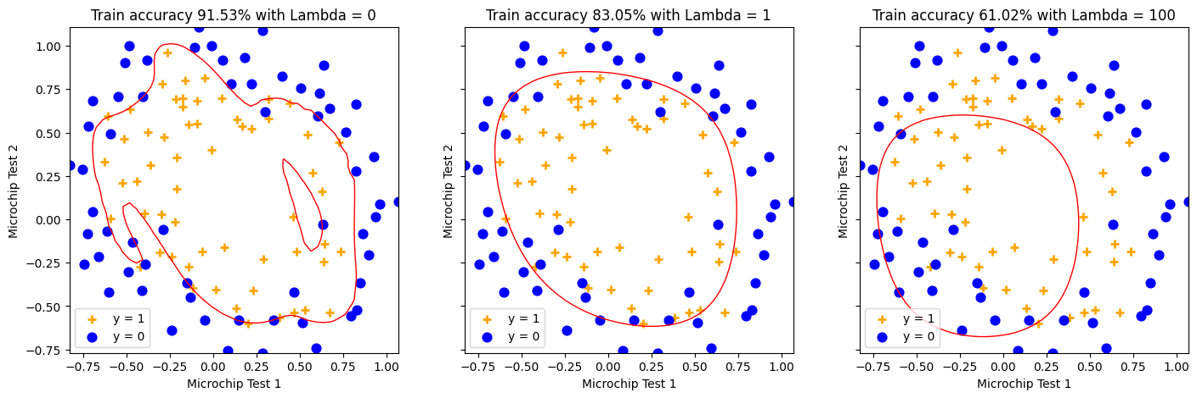

The code above shows Regularized Logistic Regression being done on a common dataset of Microchips, that aims to classify the microchips into two classes, being acceptable or defective.

First, the data is expanded into a polynomial of degree 6 using the PolynomialFeatures function, allowing the classifier to understand more complex, non-linear boundaries within the dataset. The Sigmoid function, along with the cost function are then defined using mathematical theory, without utilizing inbuilt libraries. This allows us to see the actual calculations peformed on the data in order to create the prediction model.

The GradientReg function calculates the regularized gradient of the regression, which is then used by the minimize function in order to caculate the optimized theta values. Finally those values are fed into the predict function, which is a binary classifier that classifies data into defective or acceptable based on if they are greater than or less than the threshold value of 0.5

The final graph plots scatter plots for 3 different values of lambda, showing how low values for lambda lead to overfitting (with a complex boundary and poor generalization), while high values of lambda lead to underfitting (with a simple boundary and high bias).

Overfitting causes the model to be highly accurate on the training data, but not accurate on other real world data. Underfitting, on the other hand, creates an extremely general model that is very conservative in its estimates.

This highlights the importance of regularization in order to control the trade-off between bias and variance in logistic regression.

Code Source:

[1] https://colab.research.google.com/drive/1O_22CzqXuaJHEO7NZe2q-FgHcGhI9eEM